PROJECT REPORT

Emerging Methods for Early Detection of Forest Fires

Submitted by

PNT2022TMID09835

Praveenkumar V - 730919106066

Naveenkumar R - 730919106055

Irfan A - 730919106029

Ragul P - 730919106068

Dhanishkumar S - 730919106018

S.NO | TITLE | PAGE.NO
1 | PROJECT OVERVIEW | 3
2 | PURPOSE | 3
3 | EXISTING PROBLEM | 4
4 | REFERENCES | 4
5 | PROBLEM STATEMENT DEFINITION | 6
6 | EMPATHY MAP CANVAS | 7
7 | IDEATION & BRAINSTORMING | 8
8 | PROPOSED SOLUTION | 9
9 | PROBLEM SOLUTION FIT | 10
10 | FUNCTIONAL REQUIREMENTS | 11
11 | NON FUNCTIONAL REQUIREMENTS | 12
12 | DATA FLOW DIAGRAM | 13
13 | SOLUTION & TECHNICAL ARCHITECTURE | 14
14 | USER STORIES | 15
15 | SPRINT PLANNING AND ESTIMATION | 17
16 | SPRINT DELIVERY SCHEDULE | 18
17 | TEST CASES | 21
18 | USER ACCEPTANCE TESTING | 22
20 | DEFECT ANALYSIS | 22
21 | TEST CASE ANALYSIS | 22
22 | PERFORMANCE MATRICS | 23
23 | ADVANTAGES | 25
24 | DISADVANTAGES | 26
25 | CONCLUSION | 27
26 | FUTURE SCOPE | 28
27 | GITHUB & DEMO LINK | 32

CHAPTER 1

INTRODUCTION

1.1 PROJECT OVERVIEW

Machine learning and deep learning play an important role in computer technology and artificial intelligence. With the use of deep learning and machine learning, human effort can be reduced in recognizing, learning, predictions and in many more areas.

Forest fire detection is the ability of computer systems to recognise Fire from various region of forest , such as fire, smoke, and so on. This project aims to let users take advantage of machine learning to reduce manual tasks in Detecting the forest fire.

1.2 PURPOSE

The main aim of our project is detection and monitoring the forest fire To minimize the effect of fire breakout by controlling in its early stage also to protect Domestic by informing about the breakout to the respective forest department as early as possible . We have implemented the IOT technology to achieve our objective.

CHAPTER 2

LITERATURE SURVEY

2.1 EXISTING PROBLEM

Some of the relevant literary works in this field are briefed below: The one fourth area of Karnataka is covered by forest, the forest and bio-diversity of the India are at the considerable chance and beneath enormous pressure. General causes of forest fire are extreme hot and aired weather, lightning and human carelessness. In order to protect these huge stretches of forest land, there need to be taken early caution measures to control of spreading fire

2.2 REFERENCES

- A Review on Early Forest Fire Detection Systems Using Optical Remote Sensing

  - P. Barmpoutis, P. Papaioannou, K. Dimitropoulos, N. Grammalidis
  - Environmental Science
  - Sensors
  - 2020

An overview of the optical remote sensing technologies used in early fire warning systems is presented and an extensive survey on both flame and smoke detection algorithms employed by each technology is provided.

- Forest Fire Detection System using LoRa Technology

  - N. Gaitan, Paula Hojbota
  - Environmental Science
  - 2020

This paper proposes a system capable of quickly detecting forest fires on long wide distance using LoRa (Long Range) technology based on LoRaWAN ( Long Range Wide Area Network) protocol which is capable to connect low power devices distributed on large geographical areas.

- Low Cost LoRa based Network for Forest Fire Detection

  - Roberto Vega-Rodríguez, Sandra Sendra, Jaime Lloret, Pablo Romero-Díaz, José Luis García-Navas

  - Computer Science, Environmental Science

2019 Sixth International Conference on Internet of Things: Systems, Management and Security (IOTSMS)

  - 2019

A low cost Long Range (LoRa) based network able to evaluate level of fire risk and the presence of a forest fire and the evaluation algorithm is based on the 3030-30 rule.

- A Survey of Machine Learning Algorithms Based Forest Fires Prediction and Detection Systems

  - F. Abid
  - Environmental Science, Computer Science
  - Fire Technology
  - 2020

A comprehensive survey of the machine learning algorithms based forest fires prediction and detection systems is presented, highlighting the main issues and outcomes within each study.

2.3 PROBLEM STATEMENT DEFINITION

Some people know about the current issues are the most important ones because it is mostly a lot in the news but sometimes other big issues that change our lives are not mentioned in the news because they are issues that can hurt us in the long run or not really important for the modern public. One issue I can tell you about is the forest fires. Sometimes people don 't notice or now about the forest fires until it is talk in the news and it 's mostly because it has done a great damage.

CHAPTER 3

IDEATION AND PROPOSED SOLUTION

3.1 EMPATHY MAP CANVAS
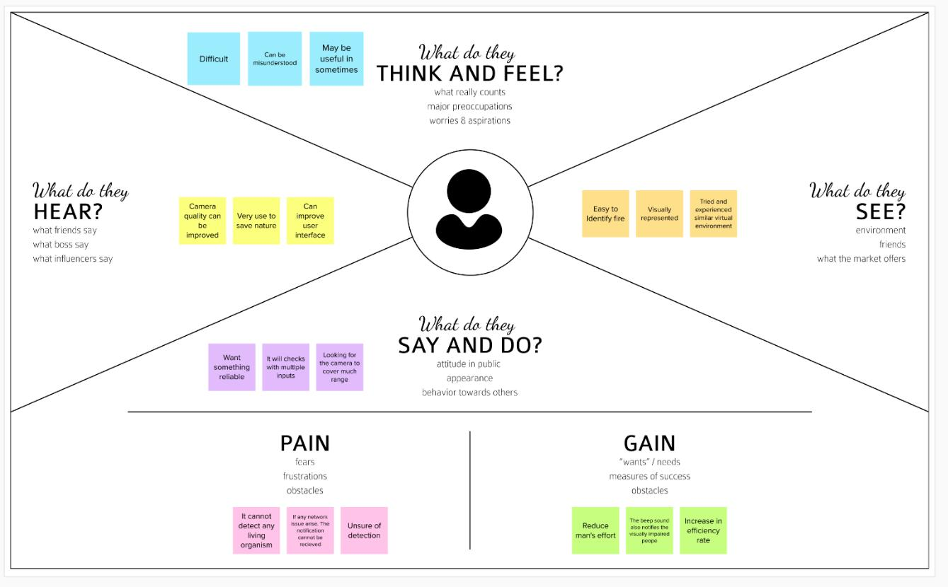
3.2 IDEATION & BRAINSTORMING
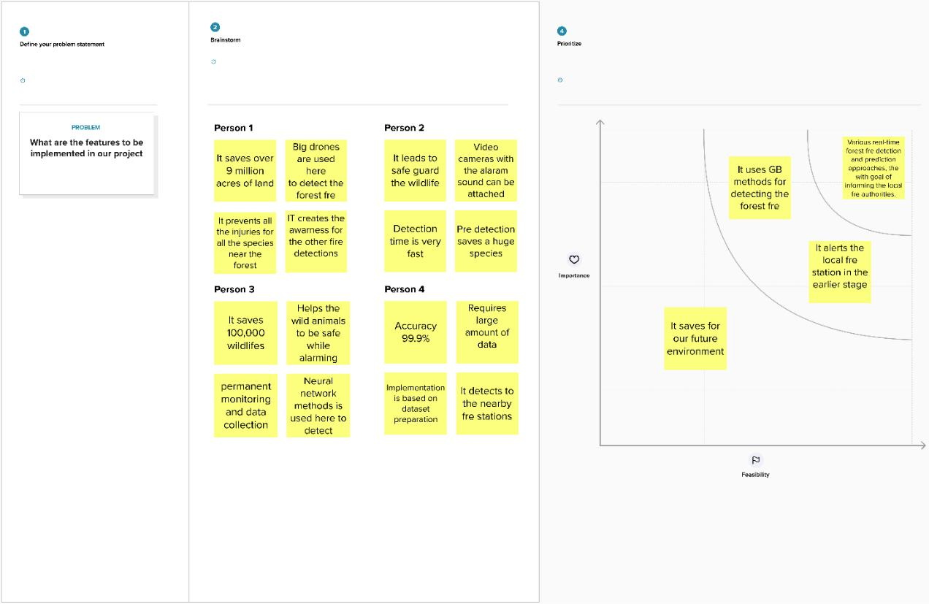
3.3 PROPOSED SOLUTION

S.No. | Parameter | Description
1. | Problem Statement (Problem to be | To find emerging methods for early detection
 | solved) | of forest fires using artificial intelligence.
 |  | In case of forest fire detection the burning
2. | Idea / Solution description | substances are primarily identified as
 |  | sceptical flame regions using a division
 |  | strategy to expel the non-fire structures and
 |  | results are verified by a deep learning model.
3. | Novelty / Uniqueness | Accurate and reliable recognition of sceptical
 |  | flame regions by means of using YOLO v3
 |  | algorithm.
 |  | 1.By using this method we can save
4. | Social Impact / Customer | environmental damage and lives of living
 | Satisfaction | beings.
 |  | 2. It is fast and accurate method to detect the
 |  | fire easily and give an alert to the forest fire
 |  | department simultaneously when the fire is
 |  | detected.
5. | Business Model (Revenue Model) | The software platform to provide the fully
 |  | autonomous processing of data received from
 |  | the camera of UAV to obtain live feed in web
 |  | App.
6. | Scalability of the Solution | It is mainly developed for detecting the forest
 |  | fire across the world and useful in
 |  | surveillance the different sections of the
 |  | forest.

3.4 PROBLEM SOLUTION FIT
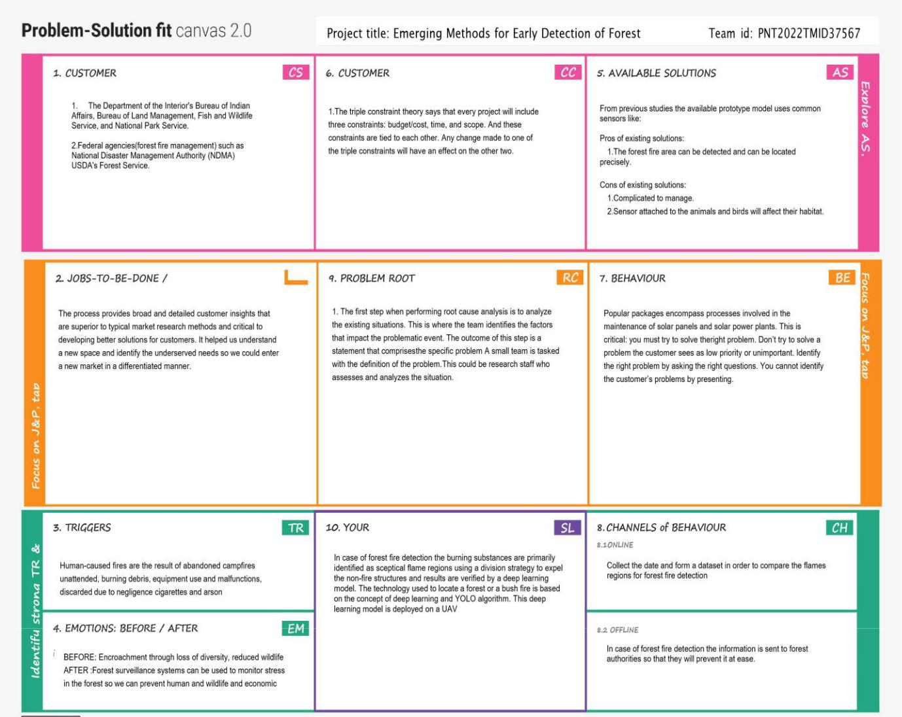
CHAPTER 4

REQUIREMENT ANALYSIS

4.1 FUNCTIONAL REQUIREMENTS

FUNCTIONALREQUIREMENTS:

-Following are the functional requirements of the proposed solution

Sn. | Functional Requirement (Epic) | Sub Requirement (Story / Sub-Task)
No
1. | User Registration | Registration through G-mail.
2. | User Confirmation | Confirmation | through | OTP.
 |  | Confirmation through mail.
3. | User Login | Can login through credentials.
4. | User Feed | The live update of the forestcover is sent to
 |  | user if there is any detection of fire
5. | User Profile | The workers profile created to give the forest
 |  | management live track of the forest.
6. | User Alert | The user receives thequick response through
 |  | alert sound or
 |  | Messages,if any fire is detected.
7. | User Application | Along with the forest management team
 |  | the citizens residing nearby forest can also
 |  | download the application for alerts.

NON-FUNCTIONALREQUIREMENTS:

-Following are the non-functional requirements of the proposed solution.

Sn. No. | Non-Functional Requirement | Description
1. | Usability | Monitoring possible danger areas and early fire
 |  | detection can greatly reduce the response time
 |  | and potential damage.
2. | Security | The environment is more secure.
3. | Reliability | The installment of model is safe.
4. | Performance | Model will achieve high accuracy.
5. | Availability | Build model is available all the time.
6. | Scalability | The instant alerts received by the forest team is
 |  | ensured.

CHAPTER 5

PROJECT DESIGN

Data Flow Diagram
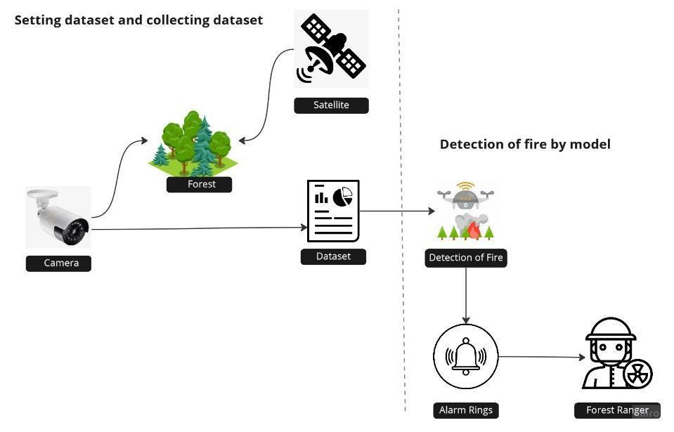

5.2 SOLUTION & TECHNICAL ARCHITECTURE
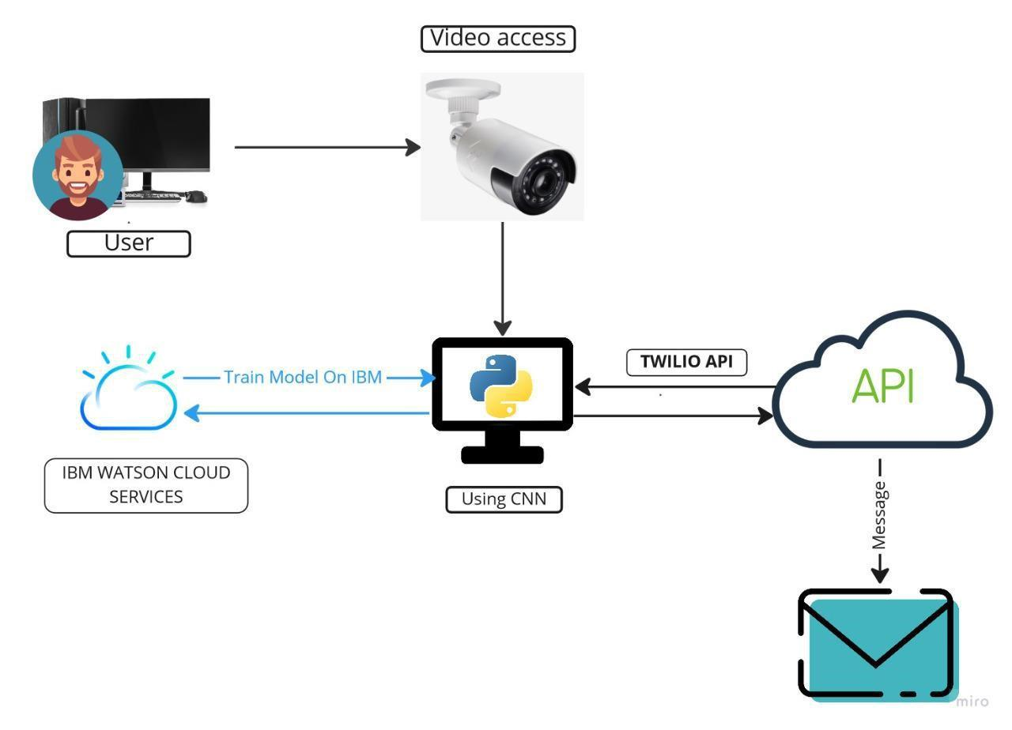
5.3 USER STORIES


User Type | Functional | User | User Story / Task Acceptance criteria | Priority | Release
 | Requirement | Story
 | (Epic) | Number

 |  |  | As a user, the | The live video
Forest | Setting up a | USN-1 | forest | captured can be | High | Sprint-1
Management | camera |  | management | monitored
Team |  |  | team has to
 |  |  | survey the forest
 |  |  | by adding camera
 |  |  | to the fire prone
 |  |  | areas.
 |  |  | As a user, the | The camera sends
 |  | USN-2 | forest | video or image to the | High | Sprint-2
 |  |  | management | forest centre
 |  |  | team can get
 |  |  | video feed which
 |  |  | is used for
 |  |  | processing
 |  |  | Along with forest | They can also get the
 |  | USN-3 | team, the NGO | view of the live | Low | Sprint-1
 |  |  | can also get | monitoring of forest
 |  |  | access of the
 |  |  | video to take
 |  |  | some early
 |  |  | measurement of
 |  |  | forest fires.
 | Image |  | By using CNN | The model should be
Technical | Classification | USN-4 | Model, the | able to identify the | Medium | Sprint-2
Team |  |  | images captured | difference between
 |  |  | by the camera is | fire and a normal
 |  |  | classified | smoke
 |  |  | accordingly by
 |  |  | testing & training
 |  |  | the model
 |  |  | The recorded | Therefore, by using
 | Using Open | USN-5 | video is under | CNN we can
 | CV |  | monitoring | determine the input
 |  |  | continuously to | layer, classify the | High | Sprint-2
 |  |  | determine the | hidden layers and
 |  |  | detection of early | send warnings through
 |  |  | video | output layer
 |  |  | Thus, after | Thus, the immediate
Alert Team | Dashboard | USN-6 | successful | response which is
 |  |  | detection of fire | required for earlier | High
 |  |  | by processing | determination through |  | Sprint-2
 |  |  | images. This, API | sending quick
 |  |  | sends the alert by | responses
 |  |  | buzzing the alarm
 |  |  | and sends
 |  |  | messages through
 |  |  | chatbot
 |  |  | They play the | They take the
Fire | Twilio API |  | most important | following measures to | High | Sprint-2
Management |  |  | role to cool the

 |  |  | fire and manage | stop fire from
 |  |  | the excess spread | spreading
 |  |  | of fire further
User Type | Functional | User | User Story / Task | Acceptance criteria | Priority | Release
 | Requirement | Story
 | (Epic) | Number
Media & | News, Radio, | USN-7 | Protecting | Thus, helping unit | Medium | Sprint-2
Nearby | Alerts, |  | wildlife, human | should be sent to
Residing |  |  | from the disaster | protect lives
People |  |  | caused

CHAPTER 6

PROJECT PLANNING AND SCHEDULING

6.1 SPRINT PLANNING AND ESTIMATION


Sprint | Functional | User | User Story / Task | Story | Priority Team Members
 | Requirement | Story |  | Points
 | (Epic) | Number

 |  |  | To analyse the fire prone
Sprint-1 | Import the | USN-1 | areas and to set the | 2 | High | Praveenkumar V
 | Required, |  | surveillance camera to |  |  | Irfan A
 | Collecting the |  | surveillance camera to
 | Collecting the |  | collect and observe the
 | Dataset |  | collect and observe the
 | Dataset |  | region continuously for
 |  |  | early detection.
 |  |  | The collected data are
Sprint-2 | Training & | USN-2 | categorized on the basis |  |  | Naveenkumar R
 | Testing of |  | of parameters set to | 1 | High | Ragul P
 | model |  | identify. To train the
 |  |  | model, CNN is used to
 |  |  | test repeatedly by
 |  |  | storing the datasets in
 |  |  | server.
 |  |  | The main task is to check
Sprint-3 | Model | USN-3 | that the model is
 | Building, |  | efficient to work in real | 1 | Medium | Dhanishkumar S
 | Reviewing |  | time. Therefore, |  |  | Praveenkumar V
 | the model |  | time. Therefore,
 | the model |  | smallest of error
 |  |  | decoded needed to be
 |  |  | corrected to avoid
 |  |  | future lags
 |  |  | The model after testing
Sprint-4 | Implementing | USN-4 | all it’s functionalities is | 2 | High | Irfan A
 | the model |  | been implemented at |  |  | Naveenkumar R
 |  |  | forest management
 |  |  | offices to get quick
 |  |  | responses from the
 |  |  | model.
 |  |  | The model should |  |  | Praveenkumar V
Sprint-4 | Connecting it | USN-5 | connect with API named | 2 | High | Praveenkumar V
 | with API |  | Twilio, which receives & |  |  | Naveenkumar R
 |  |  | Twilio, which receives & |  |  | Irfan A
 |  |  | sends the management |  |  | Irfan A
 |  |  | sends the management |  |  | Ragul P
 |  |  | with messages. |  |  | Ragul P
 |  |  | with messages. |  |  | Dhanishkumar S

6.2 SPRINT DELIVERY SCHEDULE

 |  |  |  |  | Story
 |  |  |  |  | Points
 | Total |  | Sprint | Sprint End | Completed | Sprint Release
Sprint | Story | Duration | Start Date | Date | (as on | Date (Actual)
 | Points |  |  | (Planned) | Planned
 |  |  |  |  | End Date)
 |  |  |  |  | ‘
Sprint-1 | 20 | 6 Days | 24 Oct | 29 Oct 2022 | 20 | 29 Oct 2022
 |  |  | 2022
Sprint-2 | 20 | 6 Days | 31 Oct | 05 Nov 2022 | 15 | 06 Nov 2022
 |  |  | 2022
Sprint-3 | 20 | 6 Days | 07 Nov | 12 Nov 2022 | 10 | 14 Nov
 |  |  | 2022 |  |  | 2022
 |  |  |  |  |  | \
Sprint-4 | 20 | 6 Days | 14 Nov | 19 Nov 2022 | 5 | 20 Nov 2022
 |  |  | 2022

CHAPTER 7

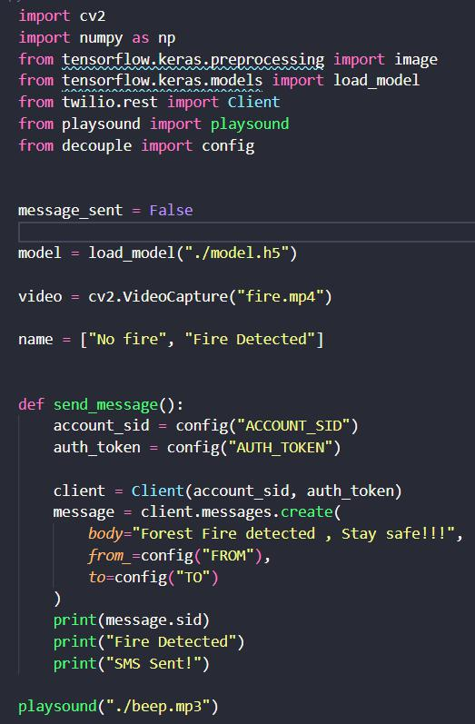
CODING & SOLUTIONING
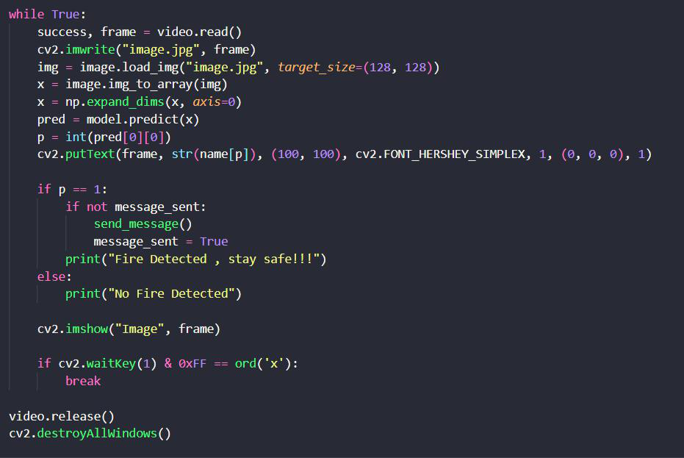
CHAPTER 8

TESTING

8.1 TEST CASES

Test case ID | Feature Type | Component |  | Test Scenario |  |  | Steps To Execute | Test Data | Expected Result |  |  |  | Actual Result | Status | BUG ID | Executed By
 |  |  |  |  |  |  |  |  |  |  |  |  |  |  |  | PRAVEENKUMAR V
 |  |  | Check if user can upload their |  |  |  | The sensor senses the fire |  | The input | image | should | be |  |  |  | IRFAN A
OP_RT_001 | Functional | Page |  |  |  |  | The sensor senses the fire | Sample 1.png | uploaded |  | to | the | Working as expected | PASS
OP_RT_001 | Functional | Page |  | file
 |  |  |  | file |  |  |  |  | application successfully
 |  |  | Check if user cannot |  |  |  | 1) The sensor senses the |  | The application should not
 |  |  |  |  |  |  | fire |  |  |  |  |  | User is able to upload |  |  | NAVEENKUMAR R
OP_RT_002 | Functional | Page |  | upload |  |  | fire | installer.exe | allow user to select a |  |  |  | User is able to upload | FAIL | BUG_HP_002 | NAVEENKUMAR R
OP_RT_002 | Functional | Page |  | upload |  |  | 2)checks with the pre- | installer.exe |  |  |  |  | any file | FAIL | BUG_HP_002 | RAGUL P
 |  |  |  | unsupported files |  |  | 2)checks with the pre- |  | non image file |  |  |  | any file |  |  | RAGUL P
 |  |  |  |  |  |  | uploads images
 |  |  |  |  |  |  | 1) The sensor senses the fire
 |  |  |  |  |  |  | 2)checks with the pre-
 |  |  | Checks | whether | the | page | uploaded images |  | The page should redirect to
OP_RT_003 | Functional | Page | redirects to the result page to |  |  |  | 3)checks if there is fire | Sample 1.png |  | the results |  |  | Working as expected | PASS
 |  |  | the given output |  |  |  | detection |  |  | page
 |  |  |  |  |  |  |  |  |  |  |  |  |  |  |  | DHANISHKUMAR S PRAVEENKUMAR V
MB_RT_001 | Functional | Backend | Checks if all the routes are |  |  |  | 1) The sensor senses the fire | Sample 1.png | All the routes should properly |  |  |  | Working as expected | PASS
 |  |  | working properly |  |  |  | 2)checks with the pre- |  |  | work
 |  |  |  |  |  |  | uploaded images |  |  |  |  |  |  |  |  | IRFAN A
 |  |  |  |  |  |  | 3)checks if there is fire |  |  |  |  |  |  |  |  | NAVEENKUMAR R
 |  |  |  |  |  |  | detection
 |  |  | Checks | whether | the | model | 1) Open the page in a specific
 |  |  |  |  |  |  | device | Sample 1.png | The model should rescale the
 |  |  |  | can |  | handle | 2) Upload the input image | Sample 1.png |  |  |  |  |  |  |  | RAGUL P
N_DC_001 | Functional | Model |  | can |  | handle | 2) Upload the input image | Sample 1 XS.png | image and predict |  |  |  | Working as expected | PASS |  | RAGUL P
N_DC_001 | Functional | Model |  | various |  | image | 3) Repeat the above steps |  |  |  |  |  |  |  |  | DHANISHKUMAR S
 |  |  |  |  |  | image | 3) Repeat the above steps | Sample 1 XL.png | the results |  |  |  |  |  |  | DHANISHKUMAR S
 |  |  |  | sizes |  |  | with different input | Sample 1 XL.png
 |  |  |  |  |  |  | 1) Open the page
 |  |  |  |  |  |  | 2) Select the input images
N_DC_002 | Functional | Model | Check if the model predicts |  |  |  |  | Sample 1.png | The model should predict |  |  |  | Working as expected | PASS
N_DC_002 | Functional | Model |  | the digit |  |  |  | Sample 1.png | the number |  |  |  | Working as expected | PASS
 |  |  |  |  |  |  |  |  |  |  |  |  |  |  |  | PRAVEENKUMAR V
 |  |  |  |  |  |  |  |  |  |  |  |  |  |  |  | IRFAN A
 |  |  | Check if the model can handle |  |  |  | 1) Open the page |  | The model should predict the |  |  |  | The model fails to
 |  |  |  |  |  |  | 1) Open the page |  |  |  |  |  | identify the digit since
N_DC_003 | Functional | Model |  | complex |  | input | 2) Select the input images | Complex Sample.png | number |  | in | the | the model is not built to | FAIL | BUG_M_001
 |  |  |  | image |  |  | 3) Check the results |  | compex image |  |  |  | handle such data |  |  | NAVEENKUMAR R
 |  |  |  |  |  |  |  |  |  |  |  |  |  |  |  | RAGUL P[
 |  |  |  |  |  |  | 1) Open the page
 |  |  |  |  |  |  | 2) Select the input image |  | The Result page must be
 |  |  |  |  |  |  | 3) Check if all the UI elements
RL_DC_001 | Functional | Result Page | Verify the elements |  |  |  | 3) Check if all the UI elements | Sample 1.png |  | displayed |  |  | Working as expected | PASS |  | DHANISHKUMAR S
 |  |  |  |  |  |  | are displayed properly | Sample 1.png |  |  |  |  | Working as expected | PASS |  | DHANISHKUMAR S
 |  |  |  |  |  |  | are displayed properly |  |  | properly |  |  |  |  |  | DHANISHKUMAR S
 |  |  |  |  |  |  |  |  |  |  |  |  |  |  |  | PRAVEENKUMAR V
 |  |  | Check if that image is |  |  |  | 1) Open the page |  | The input image should be |  |  |  | The size of the input
 |  |  |  |  |  |  | 2) Select the input image |  |  |  |  |  | The size of the input |  |  | NAVEENKUMAR R
RL_DC_002 | Functional | Result Page |  | displayed |  |  | 2) Select the input image | Sample 1.png |  | displayed |  |  | image exceeds the | FAIL | BUG_RP_001 | NAVEENKUMAR R
RL_DC_002 | Functional | Result Page |  |  |  |  | 3) Check if the input image | Sample 1.png |  |  |  |  | image exceeds the | FAIL | BUG_RP_001 | IRFAN A
 |  |  |  | properly |  |  | 3) Check if the input image |  |  | properly |  |  | display container |  |  | IRFAN A
 |  |  |  |  |  |  | are displayed |  |  |  |  |  | display container
 |  |  |  |  |  |  | 1) Open the page
 |  |  | Checks whether the |  |  |  | 2) Select the input image |  | The | other | predictions
 |  |  |  |  |  |  | 3) Check if all the other |  | The | other
RL_DC_003 | Functional | Result Page |  | displayed prediction |  |  | 3) Check if all the other | Sample 1.png | should be displayed |  |  |  | Working as expected | PASS
RL_DC_003 | Functional | Result Page |  |  |  |  | predictions are displayed
 |  |  |  | is accurate |  |  | predictions are displayed |  | properly |  |  |  |  |  |  | RAGUL P
 |  |  |  |  |  |  |  |  |  |  |  |  |  |  |  | PRAVEENKUMAR V

8.2 USER ACCEPTANCE TESTING

8.2.1 DEFECT ANALYSIS

 |  | Resolution |  |  | Severity 1 |  |  | Severity 2 |  |  |  | Severity 3 |  |  |  | Severity 4 |  |  |  | Total
 |  | By Design |  | 1 |  |  | 1 |  |  | 1 |  |  |  | 0 |  |  |  | 3
 |  | Duplicate |  | 0 |  |  | 0 |  |  | 0 |  |  |  | 0 |  |  |  | 0
 |  | External |  | 0 |  |  | 0 |  |  | 2 |  |  |  | 0 |  |  |  | 2
 |  | Fixed |  | 3 |  |  | 1 |  |  | 0 |  |  |  | 1 |  |  |  | 5
 |  | Not Reproduced |  | 0 |  |  | 0 |  |  | 0 |  |  |  | 1 |  |  |  | 1
 |  | Skipped |  | 1 |  |  | 0 |  |  | 1 |  |  |  | 0 |  |  |  | 2
 |  | Won’t Fix |  | 1 |  |  | 0 |  |  | 0 |  |  |  | 0 |  |  |  | 1
 |  | Total |  | 6 |  |  | 3 |  |  | 4 |  |  |  | 3 |  |  |  | 14

8.2.2 TEST CASE ANALYSIS

 |  | Section |  |  | Total |  |  |  | Not |  |  |  | Fail |  |  |  | Pass
 |  | Section |  |  | Cases |  |  |  | Tested |  |  |  | Fail |  |  |  | Pass
 |  | Client Application |  | 10 |  |  | 0 |  |  |  | 2 |  |  |  | 8
 |  | Security |  | 3 |  |  | 0 |  |  |  | 2 |  |  |  | 2
 |  | Performance |  | 2 |  |  | 0 |  |  |  | 1 |  |  |  | 1
 |  | Exception Reporting |  | 3 |  |  | 0 |  |  |  | 0 |  |  |  | 3

CHAPTER 9

RESULTS

9.1 PERFORMANCE METRICS
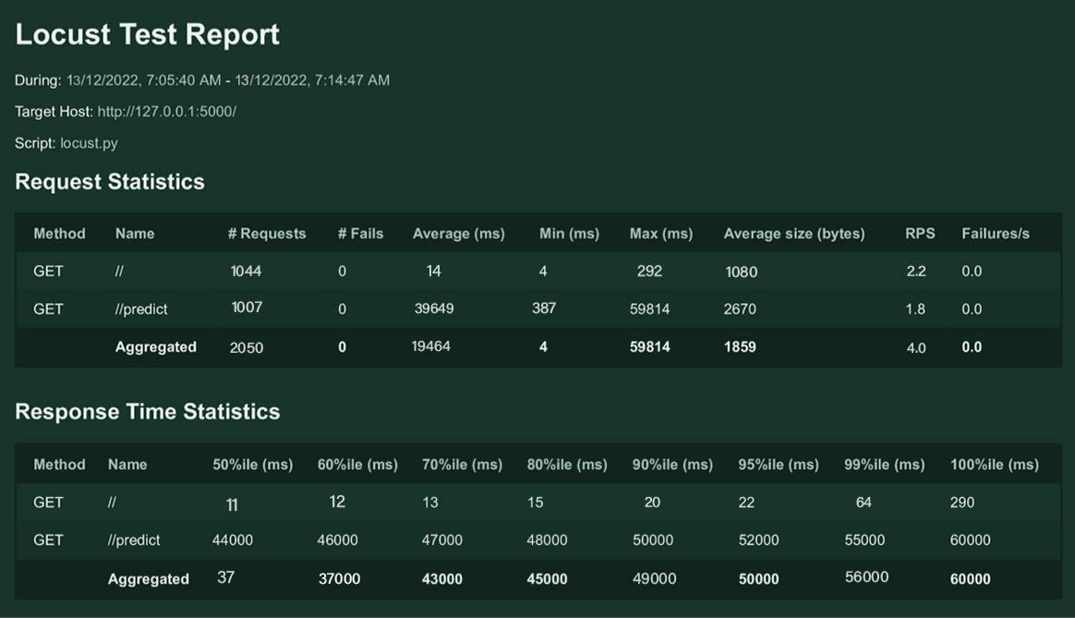
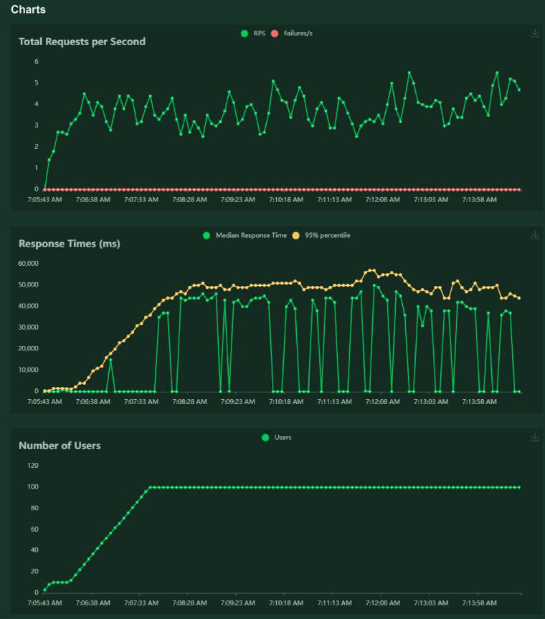
CHAPTER 10

ADVANTAGES & DISADVANTAGES

ADVANTAGES

The proposed system detects the forest fire at a faster rate compared to existing system. It has enhanced data collection feature. The major aspect is that it reduces false alarm and also has accuracy due to various sensors present. It minimizes the human effort as it works automatically. This is very affordable due to which can be easily accessed. The main objective of our project is to receive an alert message through an app to the respective user.

DISADVANTAGES

The electrical interference diminishes the effectiveness of radio receiver.

The main drawback is that it has less coverage range areas.
CHAPTER 11

CONCLUSION

This type of system is the first of its kind to ensure no further damage is then to forests when there is fire breakout and immediately a message is sent to the user through the App. Immediate response or early warning to a fire breakout is mostly the only ways to avoid losses and environmental, cultural heritage damages to a great extent. Therefore the most important goals in fire surveillance are quick and reliable detection of fire. It is so much easier to suppress fire while it is in its early stages. Information about progress of fire is highly valuable for managing fire during all its stages. Based on this information the firefighting staff can be guided on target to block fire before it reaches cultural heritage sites and to suppress it quickly by utilizing required firefighting equipment and vehicles. With further research and innovation, this project can be implemented in various forest areas so that we can save our forests and maintain great environment.

CHAPTER 12

FUTURE SCOPE

Some of the improvements that can be made to this project are as follows:

Additional pump can be added so that it automatically sends water when there is a fire breakout. Also industrial sensors can be used for better ranging and accuracy.

This project has endless potential and can always be enhanced to become better. Implementing this concept in the real world will benefit several industries and reduce the workload on many workers, enhancing overall work efficiency.

APPENDIX

SOURCE CODE
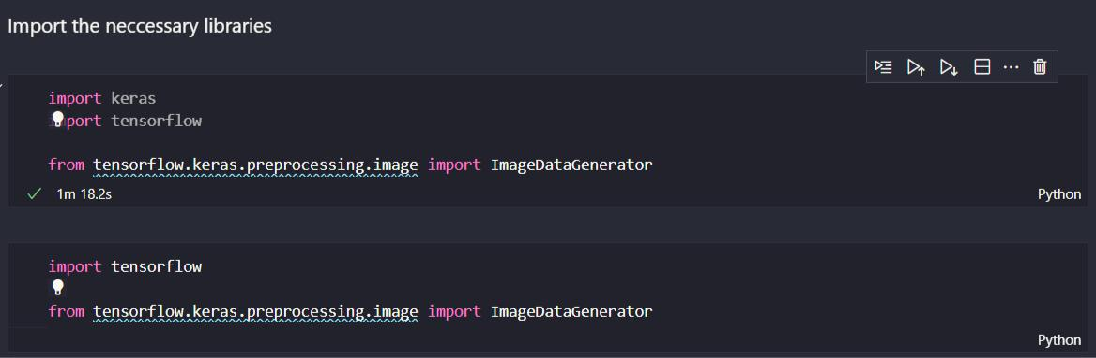
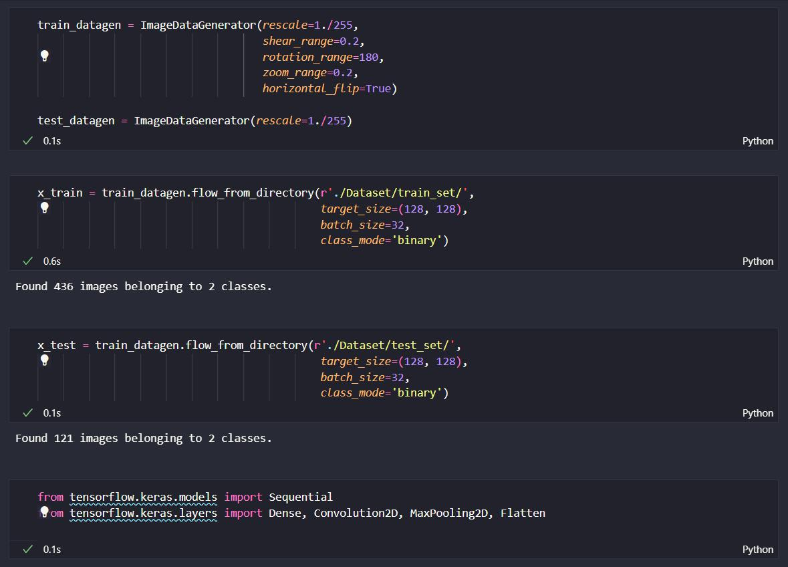
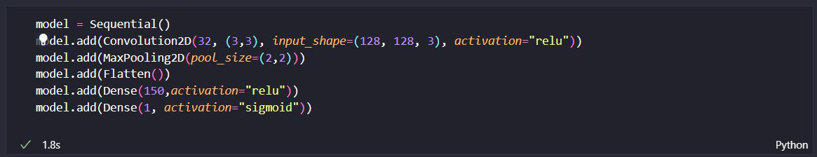
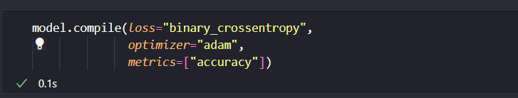
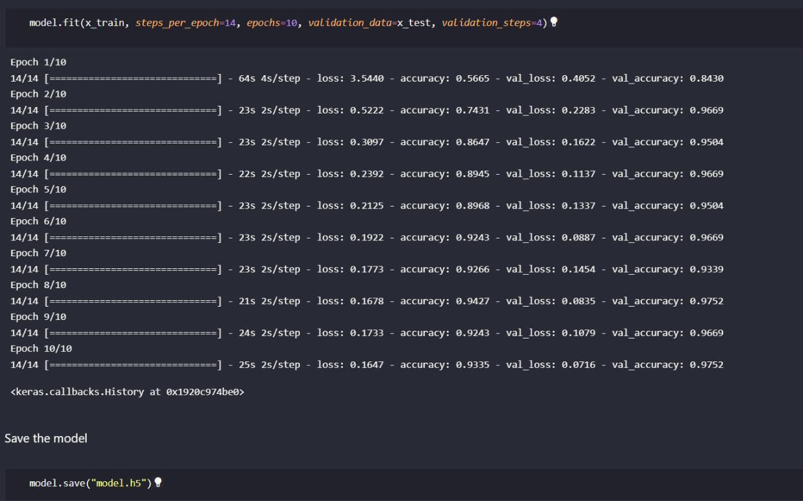
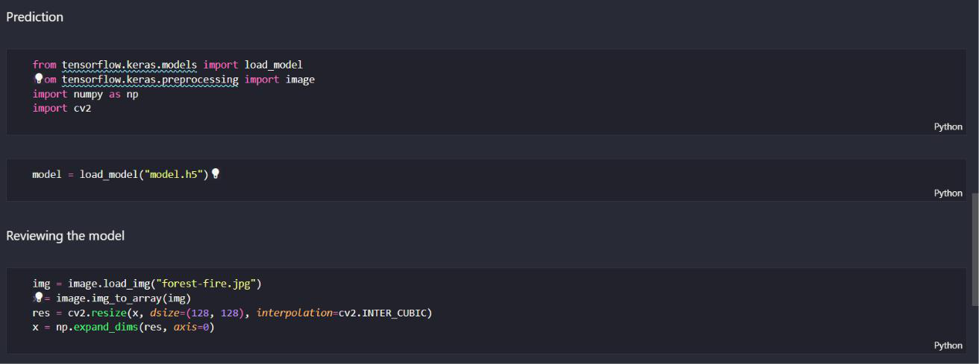
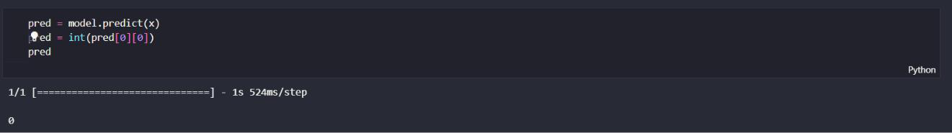

Fire.py ( Main file )
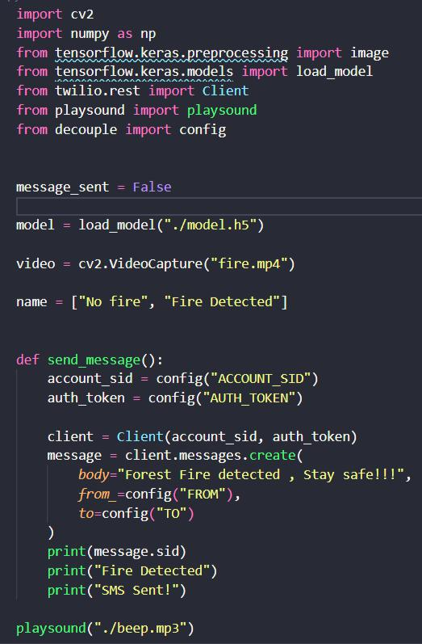
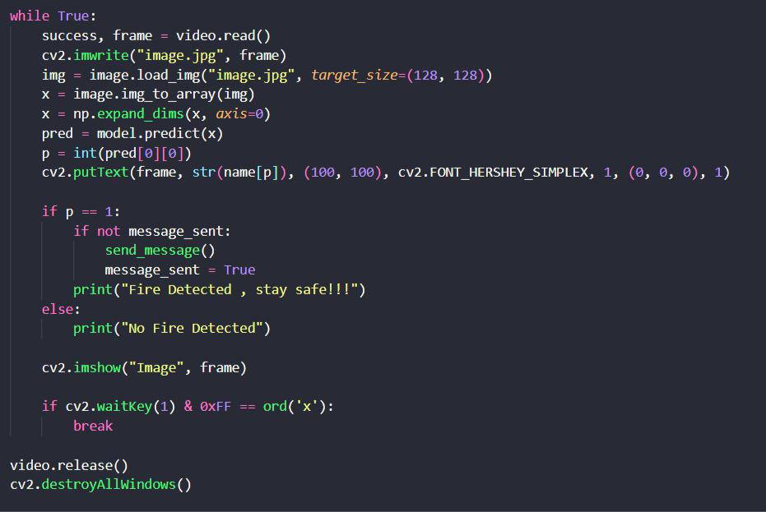

GITHUB

https://github.com/IBM-EPBL/IBM-Project-21305-1659777222

PROJECT DEMO

https://bit.ly/ForestfiredetectionProject-demovideo

